C O N C E P T P A P E R
24-26 November 2014, New Delhi, India
Major organizers of the international event:
UNESCO in close cooperation with Brotherhood,
We Care Filmfest and Global Rainbow Foundation

With the support of Government of India
Ministry of Social Justice and Empowerment,
Department of Disability Affairs Disability Affairs
Ministry of Human Resource Development
Department of University and Higher Education
Indian National Commission for Cooperation with UNESCO

Table of Contents

Background 3

Major Objectives of the International Event 5

Structure of the International Event 6
Expected outcomes of the international event 7
Expected participants 7

International Event Convenors 7
UNESCO 8
Brotherhood and We Care Filmfest 8
Government of India, Ministry of Social Justice and Empowerment, Department of Disability Affairs 9
Government of India, Ministry of Human Resource Development, Department of Higher Education, Indian National Commission for Cooperation with UNESCO 9

Contact information 9
UNESCO Headquarters 9
UNESCO Office in New Delhi 9
Film festival 10
Conference Venue 10

Web links 10

Background

Today, there are more than 650 million persons with disabilities around the world. The World Disability Report, published by the World Health Organization (WHO) and World Bank (WB), states that 15% of the world population have some form of disability. Over 80% of those with disabilities live in isolated rural areas in developing countries. Some 62 million children of primary school age have a disability and 186 million children with disabilities have not completed primary school education. Furthermore, fewer than 2% of children with disabilities in developing countries are in school.

Persons with disabilities often suffer from discrimination and social exclusion, have fewer economic opportunities and higher rates of poverty. Their daily lives are specifically impeded through inadequate legal frameworks to protect their rights, a lack of financial and skilled human resources to carry out their activities, a lack of opportunities to access education and information, the high cost of assistive technologies (ATs), a lack of services available to them, the absence of large networks of disability groups to share resources with each other, and many other factors.

Disability is a cross-cutting issue and all the Millennium Development Goals (MDGs) have relevance to disability and persons with disabilities. Although the commitment of the United Nations to the rights of persons with disabilities and their inclusion are implied in all aspects of the Goals, this does not automatically result in their inclusion in either general or targeted efforts to meet MDGs.

The commitment of the United Nations (UN) to the rights of persons with disabilities was codified into the United Nations Convention in 2006. The UN Convention on the Rights of Persons with Disabilities (UNCRPD), together with the World Programme of Action and the Standard Rules on the Equalization of Opportunities for Persons with Disabilities, provides a strengthened international normative framework for disability-inclusive development. It has provided an impetus and a unique platform from which to engage the broader global development community.

However, the current global economic downturn has had devastating effects on the lives of many in both developed and developing countries. The pace of recovery is slow and uneven across countries, especially in developing economies, and the recovery will not be enough to make any meaningful improvements in social conditions in most countries. Indeed, a possible decrease in public spending could even make the situation worse for persons with disabilities, who already do not have adequate access to social services, education and job opportunities, particularly in developing countries.

Against the backdrop of multiple global crises and emerging challenges, governments, together with the development community, have responded in various ways by introducing specific policy measures and new initiatives. The challenge now is to take the situations of persons with disabilities fully into account and to incorporate their needs as well as to make responses available to everyone.

The UNCRPD reaffirms the human rights of disabled people and signals a further major step in their journey to becoming full and equal citizens. The UNCRPD provides a comprehensive framework that ensures the equal enjoyment of universal human rights and fundamental freedoms by persons with disabilities. It is also a guiding document for countries that aim to address policy-making and legislation issues that are relevant to the needs of persons with disabilities, as well as to provide better access to education and information, encourage a wide range of stakeholders create and provide more accessible and affordable content, services and products for persons with disabilities, and to empower them to participate in political, economic and cultural life.

The growing number of Member States that have ratified the UNCRPD and its optional protocol indicates a paradigm shift in the way we think about disability. It also shows a move away from the association of persons with disabilities with charity, medical treatment and social protection. Since the adoption of the UNCRPD in 2006, some progress has been made to improve access to information and knowledge for persons with disabilities around the world.

However, little attention has been focused on realizing the UNCRPD principles in the core sectors of education and employment. It therefore becomes imperative to realize UNCRPD from the ground up, by learning about and documenting local and innovative practices. Numerous reports and innovative projects have already provided evidence that Information and Communication Technologies (ICTs) have the potential to make significant improvements in the lives of these persons, allowing them to enhance their social and economic integration in communities by enlarging the range of activities available to them.

Against this background, there is a need for wider dialogue among the various stakeholders –government, persons with disabilities and their families, disabled people’s organizations, civil society, and the private sector – at local, national and international levels, to better understand the challenges, to remove the barriers and to harness the potential of persons with disabilities. There is a need for dialogue on how to increase the choices and opportunities available to people with disabilities, how to improve their access to education, information and knowledge, and how to extend their capabilities, particularly in the context of low-skilled and poorly regulated labour markets.

Building on the UNCRPD and its unique mandate for education, communication and information within the United Nations system, UNESCO, in close cooperation with international, regional and national partners, is pleased to announce plans to host an international conference entitled “From Exclusion to Empowerment: The Role of Information and Communication Technologies for Persons with Disabilities” in New Delhi, India from 24 to 26 November 2014.

Major Objectives of the International Event
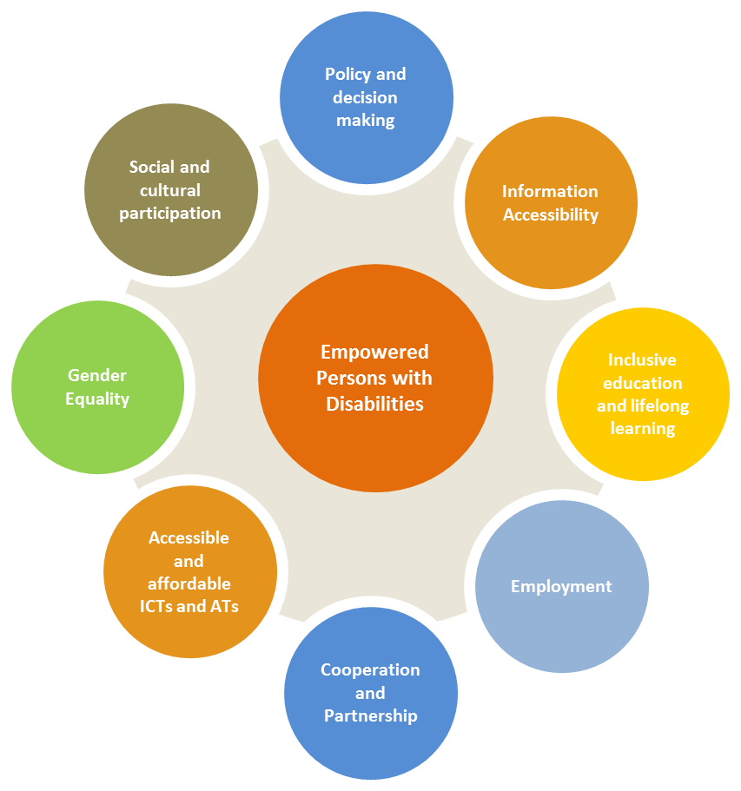
The major objective of this international conference is to promote the human rights and fundamental freedoms of persons with disabilities and to encourage all stakeholders to take concrete measures for the empowerment of persons with disabilities through the use of ICTs.

The conference will establish clear thematic linkages between the following articles of the UN Convention (UNCRPD):

      - Article 6 – Women with Disabilities;
- Article 9 – Accessibility;
- Article 21 – Freedom of Expression and Opinion, Access to Information;
- Article 24 – Education;
- Article 27 – Work and employment;
- Article 32 – International cooperation.

Other objectives of the conference are to:

- Raise public awareness among policy and decision makers, disabled people organizations, public and private organizations, education, industry, information and media professionals as well as civil society at large, of the significance and complexity of disability issues, and the sense of urgency for taking concrete measures and action.
- Provide assistance to UNESCO’s Member States in the implementation of international commitments regarding the inclusion and empowerment of persons with disabilities and ICTs in a comprehensive and coherent manner.
- Identify existing challenges and barriers arising from the most recent international experiences in different areas of disability that may help to develop programmes and services for people with disability and people working in the field.
- Show case technical solutions and share good practices as well as encourage constructive dialogue among people working in the disability field.
- Better understand and promote the application of affordable and accessible ICTs and ATs for persons with disabilities to access information and knowledge, education, rehabilitation, employment and to participate more fully in society.
- Encourage various stakeholders to design and provide accessible and affordable content, services and concrete solutions, as well as programmes for persons with disabilities, particularly to access information and knowledge.
- Encourage national and international cooperation among various stakeholders.
- Mobile resources for joint initiatives; and
- Propose an action plan on the implementation of UNCRPD (Outcome document).

Structure of the International Event

The international conference programme will include plenary and breakout parallel sessions dedicated to various thematic issues.

There will be six plenary sessions: one at the opening and one at the closing of the event, and one each day for each themed track with a keynote speaker. Keynote speakers for the plenary sessions will be selected by UNESCO and the Planning Committee and will deliver presentations (30 minutes) followed by a discussion with the audience. One of the plenary sessions will be dedicated to the adoption of the Conference Declaration and Action Plan.

A special session will be dedicated to the film festival. The 16 breakout parallel sessions will concentrate on specific thematic issues linked to the UNCRPD as follows:
 | Media Event
 | Film Festival
 | Exhibition
 | International conference
 | Women with Disabilities (Article 6) and International cooperation (Article 32)
 | Inclusive  Education  (Article 24) | Freedom of Expression  and Opinion,  Access to Information  (Article 21) | Participation in cultural life, recreation,  leisure and sport (Article 30) | Accessibility  (Article 9) | Work  and  employment  (Article 27)
 | Training – interactive workshops for national participants
 | Outcome Document for targeted initiatives
There will also be smaller, more interactive and participatory breakout sessions made up of presentations and panels. The leader of the themed track will be asked to provide inputs to the preparation of the Conference Declaration.

Expected outcomes of the international event

- Recommendations provided for various stakeholders on specific actions in order to improve the status quo of people with disabilities with regard to the role of ICTs in increasing access to education, public information, social services, and job opportunities.
- Innovative solutions, best practices and case studies from different parts of the world documented and shared that illustrate stakeholders’ engagement and benefits for introduction of policies, products and services to harness the potential of people with disabilities.
- Outcome document prepared capturing the main debates, discussions and solutions presented for informed decision making, then globally distributed among various stakeholders and integrated into new follow up activities.
- Best films produced and distributed within the framework of the international film festival for international awareness-raising and social mobilization campaign.
- All stakeholders encouraged to take concrete actions for the empowerment of persons with disabilities through the use of Information and Communication Technologies (ICTs).
- Partnership initiated, communication forged and networks established among various stakeholders.
- New contacts established projects initiated, services and technical solutions integrated in order to access information and knowledge, education, rehabilitation and employment persons with disabilities in society.

Expected participants

More than 500 participants are expected from around the world, including:
- Policy and decision makers;
- Representatives of Ministries and Departments of Education, Information and Communications, Social Affairs and Health, Women and Child Development;
- International organization representatives;
- Teacher training institutes;
- Disabled peoples’ organizations, civil society;
- Representatives of ICT, media and film industry;
- Information and media professionals, and
- Other stakeholders.

Working Language of the international event is English.

International Event Convenors

UNESCO Communication and Information Sector
UNESCO New Delhi Office
Brotherhood, We Care Filmfest
UN Information Centre for India and Bhutan

With support of Government of India,
Ministry of Social Justice and Empowerment, Department of Disability Affairs
and Ministry of Human Resource Development, Department of Higher Education
Indian National Commission for Cooperation with UNESCO

UNESCO

UNESCO promotes the concept of Knowledge Societies which are inclusive, pluralistic, equitable, open and participatory. UNESCO is also committed to the implementation of the Plan of Action adopted by the World Summit on the Information Society (WSIS), which includes two important areas for persons with disabilities, namely access to information and knowledge and capacity building. In the framework of these concepts, UNESCO advocates the rights and needs of persons with disabilities and fosters the effective use of ICTs that are accessible, adaptive and affordable.

Furthermore, UNESCO, as one of the specialized UN agencies, promotes and supports the implementation of the UNCRPD and reaffirms that all persons, with all types of disability, can enjoy all human rights and fundamental freedoms. A number of the UNCRPD principles are linked to UNESCO’s core mandate and actions. UNESCO believes that in the areas of its competence, the Organization has a moral duty to work towards the removal of all barriers preventing the meaningful participation of people with disabilities in their respective societies, and is committed to investing its expertise and efforts to unlock their vast potential.

The Organization believes that ICTs are particularly effective tools in the outreach to marginalized communities, both in terms of accessing information and knowledge and in encouraging participation in the development of ICT content and applications by persons with disabilities.

Brotherhood and We Care Filmfest

BROTHERHOOD has been using audiovisual media since 2002 to initiate discussions and dialogue for the integration of people with disabilities into the mainstream of society. Through several projects, they have demonstrated that film and documentaries can be a powerful medium for educating the public about disability issues, dispelling myths, stereotypes and misconceptions about persons with disabilities, and promoting a new approach to disability which guarantees equal rights and opportunities and equal access.

Creating awareness on disability issues through the medium of films is a new concept for India, although such festivals have been held before in various countries around the world. Research shows that, in most countries, the majority of children with disabilities do not know any disabled adults and, consequently, many have difficulty in imagining their future. Audio-visual media can provide opportunities for them to observe adults with disabilities carrying out a wide variety of activities – in other words, introducing them to positive role models.

BROTHERHOOD is a pioneer in organizing film festivals on disability issues in India. Since 2003 they have held five international Special Film Festivals, jointly organized by the World Bank, the National Trust, Tamana Welfare Society and Asian Academy of Film and Television, Icongo, Iridium Interactive etc. The aim of the We Care Film Festivals is to create awareness about disability issues through the medium of films and to foster integration in society by spreading the message of ability. The festival is aimed at giving a fillip to the rights-based approach, where persons with a disability are considered persons first and foremost. We Care aims to remove the myths, misconceptions, prejudices and stereotypes about disabled persons and disability in society, through the medium of films.

Government of India, Ministry of Social Justice and Empowerment,
Department of Disability Affairs

The Ministry of Social Justice & Empowerment is entrusted with the empowerment of the disadvantaged and marginalized sections of the society. The Ministry has been implementing various programmes/schemes for social, educational and economic development of the target groups. As a result there has been considerable improvement in the welfare of these groups. The Department of Disability Affairs has been created on 12th May 2012. As per Census 2001, the population of persons with disabilities in the country was estimated at 2.2. crore.

Government of India, Ministry of Human Resource Development, Department of Higher Education, Indian National Commission for Cooperation with UNESCO

The Department of Higher Education, is responsible for the overall development of the basic infrastructure of Higher Education sector, both in terms of policy and planning. Under a planned development process, the Department looks after expansion of access and qualitative improvement in the Higher Education, through world class Universities, Colleges and other Institutions.

Contact information

UNESCO Headquarters | UNESCO Office in New Delhi
Mr Indrajit Banerjee  Director, Knowledge Societies Division,  Communication and Information Sector, UNESCO  Email: i.banerjee@unesco.org | Mr Shigeru Aoyagi  Director and UNESCO Representative to Bhutan, India, Maldives and Sri Lanka  UNESCO Office in New Delhi  Email: s.aoyagi@unesco.org
Ms Irmgarda Kasinskaite-Buddeberg  Programme Specialist, Knowledge Societies Division,  Communication and Information Sector, UNESCO  Email: i.kasinskaite@unesco.org | Mr Anirban Sarma  National Programme Officer,  UNESCO Office in New Delhi  Email: a.sarma@unesco.org, phone: +91 11 26713000
Ms Rajarajeswari Pajany  Assistant, Knowledge Societies Division,  Communication and Information Sector, UNESCO Email: r.pajany@unesco.org | Ms Nidhi Ralhan  National Programme Officer,  UNESCO Office in New Delhi  Email: n.ralhan@unesco.org, phone: +91 11 26713000

Film festival

Ms Kiran Mehra-Kerpelman  Director  UN Information Centre for India and Bhutan  55, Lodi Estate  New Delhi-110003, India  Email: unicindia@unicindia.org | Mr Satish Kapoor  United Nations Volunteer and Recipient of Acharya Vinobha Bhave National Volunteer Award  Founder and Director, Brotherhood and  We Care Filmfest  Director/Secretary, Concerned Action (CAN)  Emails: wecarefilmfest@gmail.com, brotherhood94@gmail.com

Conference Venue

The conference venue is Vigyan Bhavan, New Delhi, India. Vigyan Bhavan is a premier convention centre of Government of India in New Delhi. Built in 1956, over the years it has been the venue of conferences of national and international stature, seminars and award ceremonies attended by distinguished world leaders and dignitaries.

Web links

For more information on the subject, we recommend you to visit:

International Conference Role of Information and Communication Technologies for Persons with Disabilities (24-26 November 2014, New Delhi, India) – website to be accessible to the public as of 10 June 2014.
http://www.unesco.org/ict-disability

UNESCO website on Access to Information and Knowledge for People with Disabilities:
http://www.unesco.org/new/en/communication-and-information/access-to-knowledge/access-for-people-with-disabilities/
Brotherhood and We Care Filmfest
http://www.wecarefilmfest.net/home.php

UN Information Centre for India and Bhutan
http://www.unic.org.in/default.php

UNenable. Factsheet on Persons with Disabilities. http://www.un.org/disabilities/default.asp?id=18
World Health Organization, World Bank (2011). World Disability Report. Geneva. http://www.who.int/disabilities/world_report/2011/en/index.html
UNESCO (2010). Education for All Global Monitoring Report. Paris. http://unesdoc.unesco.org/images/0018/001866/186606E.pdf
United Nations (2010). Keeping the promise: realizing the Millennium Development Goals for persons with disabilities towards 2015 and beyond. Report of the Secretary-General, sixty-fifth session, July 2010, Item 27 (b) of the provisional agenda. http://www.un.org/disabilities
To be confirmed.
http://www.unesco.org/new/en/
http://www.unesco.org/new/en/communication-and-information/access-to-knowledge/access-for-people-with-disabilities/
http://www.wecarefilmfest.net/home.php
http://socialjustice.nic.in/
http://mhrd.gov.in/higher_education
http://www.wca2014.org/wp-content/uploads/2013/07/vigyan-bhavan.jpg

